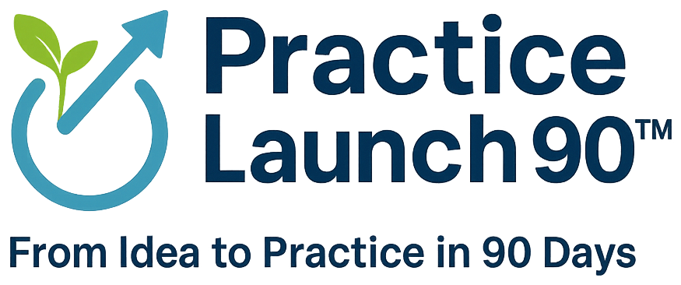 | FREE RESOURCE

The Practice Preparation Checklist
Everything it takes to open an independent practice, in one list.
From legal setup and budgeting to EHR selection, payer enrollment, and credentialing, use this to check your progress and find the gaps before they cost you time or money. Practice Launch 90 organizes the work into three phases, shown here.
Phase 1: Foundation and Regulatory Readiness
Days 1 to 30 Lay the legal, compliance, and financial foundation to operate independently.
Vision, mission, and business plan
☐ Confirm your practice vision and mission
☐ Build a business plan from a Business Model Canvas, including a multi-year roadmap that guides the next years of operation
Legal and entity
☐ Form your business entity (LLC or PLLC), get your EIN, and open business banking
☐ Register your DBA and professional entity where your state requires it
☐ Confirm your business license and any local permits (site-dependent)
Identifiers and credentialing roadmap
☐ Obtain your NPI (Type 1 for you, Type 2 for the organization)
☐ Set up and attest your CAQH profile
☐ Map payer enrollment for Medicare, Medicaid, and commercial plans
☐ Register for DEA and state controlled-substance authority if you prescribe
☐ Confirm whether you need a CLIA waiver for in-office testing
Compliance framework
☐ Complete a HIPAA Security Risk Analysis and address OSHA requirements
☐ Put your business associate agreements (BAAs) in place
☐ Set up your Good Faith Estimate and No Surprises Act process
☐ Build your patient intake and consent packet
Risk and insurance
☐ Secure malpractice, general liability, and cyber coverage, plus workers' compensation and business property if you have staff or a location
Financial foundation
☐ Build a startup budget and a twelve-month pro forma
☐ Set up accounting, payroll, banking, and merchant services
Care model and EHR strategy
☐ Confirm your care model (insurance-based, hybrid, direct-care, or a mix)
☐ Assess your EHR options, including cost, complexity, and any migration plan
End of Phase 1: your Practice Foundation Package. One organized file with everything that makes the practice real.
Phase 2: Operations, Technology, and Staffing
Days 31 to 60 Stand up the tools, systems, and people the practice needs to run from day one.
EHR and clinical systems
☐ Select, configure, or migrate your EHR
☐ Build scheduling templates and visit cadence
☐ Turn on telehealth and your patient portal
Technology and communications
☐ Set up a business phone system with auto-attendant, voicemail, and after-hours routing
☐ Put HIPAA-compliant email and secure fax in place
☐ Set up your network, devices, secure storage, backup, and disaster recovery
☐ Establish a cybersecurity baseline (multi-factor authentication, endpoint protection)
Revenue cycle
☐ Build billing workflows (coding, claims, collections, denial prevention)
☐ Finalize your fee schedule and patient financial policies
Staffing and people
☐ Design your staffing model, write job descriptions, and plan onboarding
Policies and procedures
☐ Create a tailored policy and procedure set mapped to federal and state requirements, not generic templates
End of Phase 2: your Operations Playbook. A working set of systems, workflows, and policies that run the day to day.
Phase 3: Go-Live, Optimization, and Scale
Days 61 to 90 Get the practice off the ground, keep it stable, and build a clear path to grow.
Go-live
☐ Run a go-live readiness check and execute your launch
☐ Plan your patient panel transition if you are leaving an employer
Performance
☐ Monitor first-month revenue
☐ Set up a KPI dashboard (panel growth, visit volume, collections, denial rate)
Growth
☐ Put a marketing and referral activation plan in motion
☐ Plan your capacity and a ninety-day post-launch optimization plan
☐ Map a scale roadmap if you are adding providers or locations
End of Phase 3: your Launch Scorecard and Growth Roadmap. A live dashboard plus a written plan for the next ninety days and beyond.
About credentialing. Insurance credentialing runs on a separate track set by the payers, and it commonly takes 90 to 120 days or longer. Many practices open on a private-pay basis or with early-approved payers before it is finished, so plan it in parallel from day one.

Feeling the weight of this list?
That is exactly what Practice Launch 90 is built for. We handle the legal, financial, operational, and technical side of your practice through a structured 90-day plan, so you can get back to what you do best: caring for patients.
 | practicelaunch90.com  info@vermonthealthcareconsulting.com  802-448-0760
  Book a Strategy Session

